Planning Instructions for VMAT CSI

1. Ensure greater than 2-5cm overlap between cranio and spinal arcs
2. The shift between isocenters should be only in longitudinal direction.
3. The length of the cranio arc should be minimized to reduce beams penetrating laterally through the shoulder - optional
4. Avoidance sectors should be used to avoid beam direct through the eyes and arms. – no avoidance sectors possible with API
5. Collimator needs to rotate small angle to avoid MLC interleave leakage effect.
6. Optimize the cranial and spinal fields together in the same plan to get 95% coverage. Split fields to separate plans for treatment.

Prescriptions:

23.4 Gy in 13fx + boost of 30.6 Gy

36 Gy in 20 fx + boost 18 Gy

12 Gy in 6 fx

Margins for targets:

PTV_Brain = Brain+ 5mm all around

CTV_Spine = SpinalCord+0.5 cmANT, +1.5cm INF, +1cm in all other directions

PTV_Spine = CTV_Spine+5mm all around

PTV_CSI=PTV_Brain+PTV_Spine

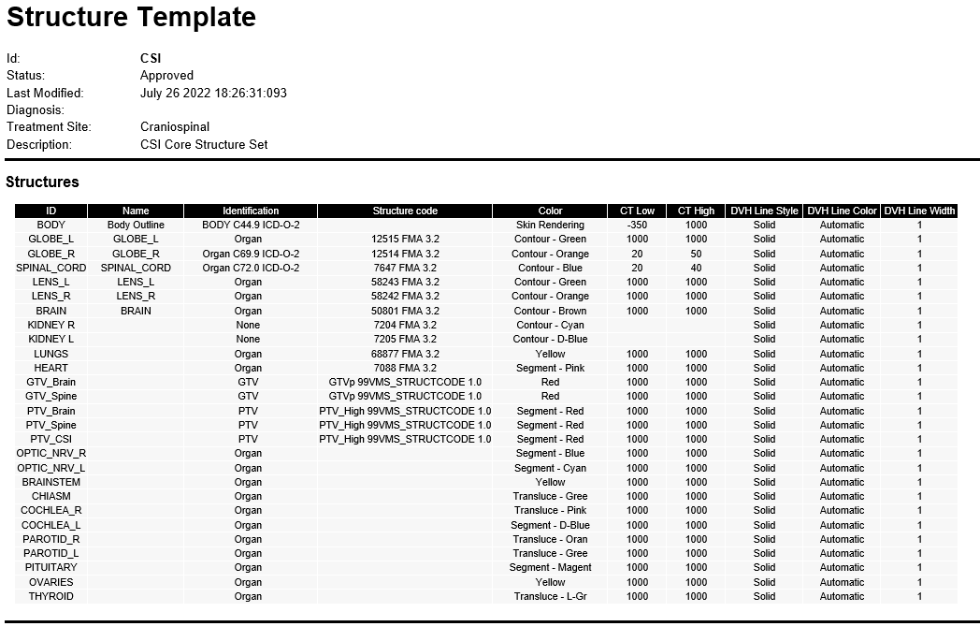

Clinical Dose Constraints

|  |  |  |  |  |
| --- | --- | --- | --- | --- |
| **Priority** | **Critical Structure** | **Dose volume constraints** | **Dmean** | **Dmax** |
|  |  | V      ≤       % | Gy | 56 Gy |
|  |  | V      ≤       % | Gy | 55 Gy |
|  |  | V57 ≤ 10 % | Gy | 59 Gy |
|  |  | V      ≤       % | Gy | 59 Gy |
|  |  | V      ≤       % | Gy | 55 Gy |
|  |  | V      ≤       % | Gy | 55 Gy |
|  |  | V      ≤       % | 35 Gy | 55 Gy |
|  |  | V      ≤       % | 26 Gy | Gy |
|  |  | V      ≤       % | Gy | 60 Gy |
|  |  | V35 ≤ 10 % | 10 Gy | 54 Gy |
|  |  | V      ≤       % | Gy | 10 Gy |
|  |  | V20 ≤ 30 % | 10 Gy | Gy |
|  |  | V      ≤       % | 5 Gy | 10 Gy |
|  |  | V      ≤       % | 20 Gy | Gy |
|  |  | V      ≤       % | 10 Gy | Gy |
|  |  | V      ≤       % | 12 Gy | Gy |
|  |  | V      ≤       % | Gy | Gy |
|  |  | V      ≤       % | Gy | Gy |